**Question 1 Salary Distribution Among Data Science Professionals:**

**"What is the distribution of salaries among data science professionals?"**

# Bottom 10 Salaries Across Data Science

When it comes to the bottom 10 salaries in the realm of Data Science, it’s intriguing to note the diverse range of earnings. Among these, Machine Learning Specialists and Compliance Data Analysts stand out, displaying a significant salary range of 30,000. Surprisingly, Machine Learning Specialists are positioned at the higher end of this range, commanding the highest wages among the bottom 10 earnings. Roles like Insight Analyst, Machine Learning Specialist, and Compliance Data Analyst display a distribution of salaries that are equally balanced around the central value.

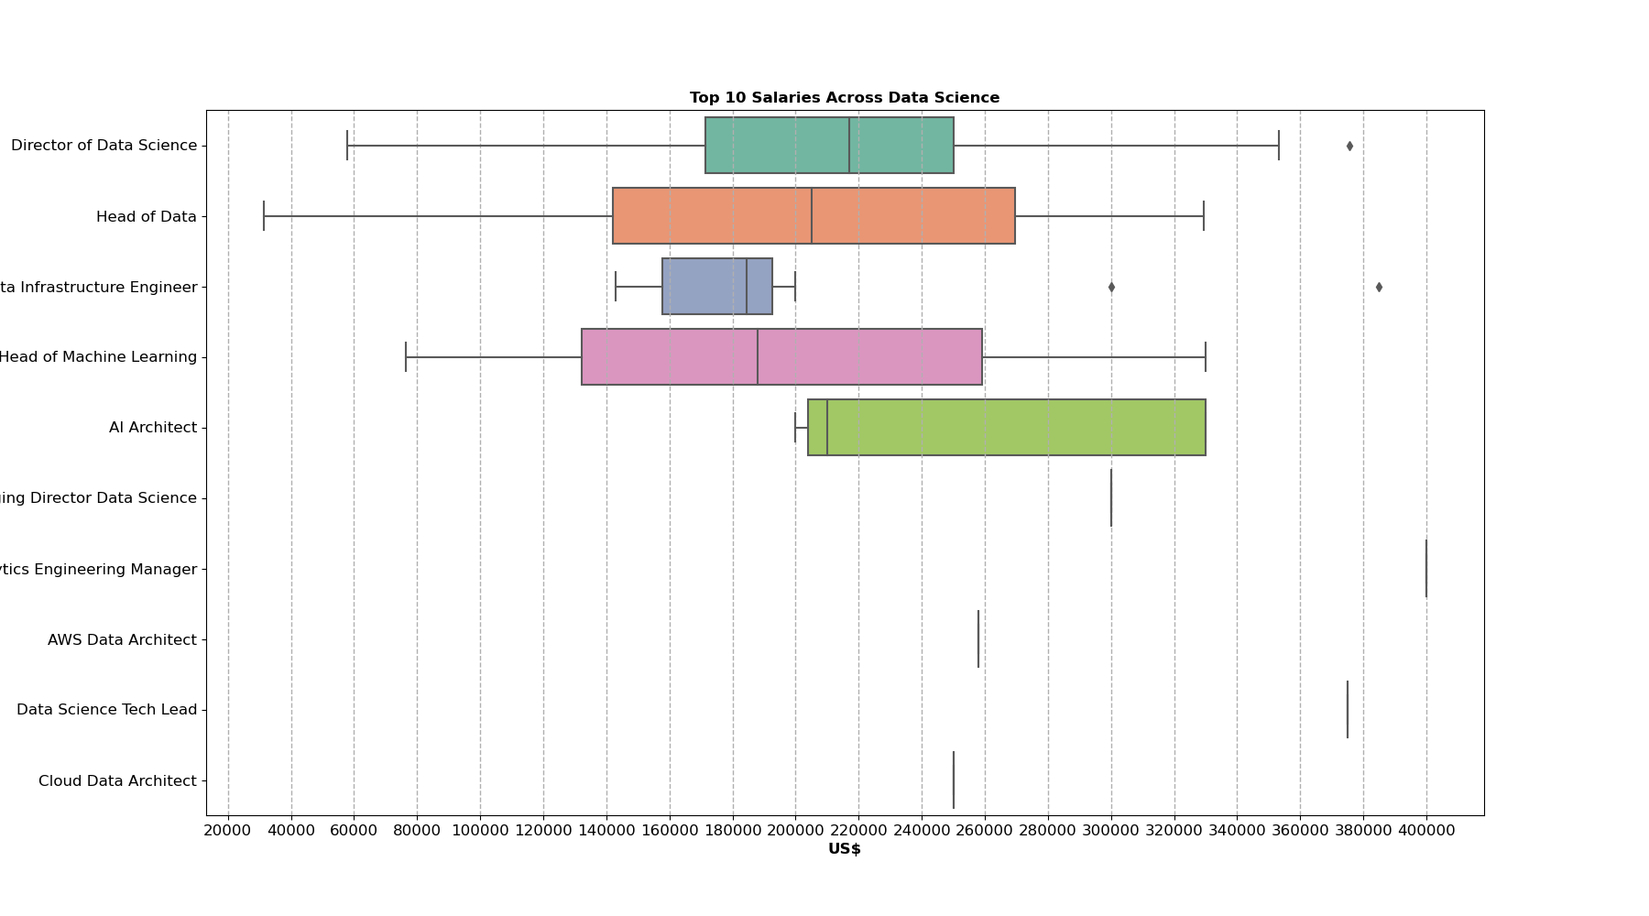

# 

# 

# Top 10 Salaries Across Data Science

Shifting our focus to the top 10 tier in Data Science, the Director of Data Science and the Head of Data appear as top picks with an impressive salary range of 300,000. The chart demonstrates that salaries for Heads of Data are evenly distributed around the central value, suggesting a normal distribution in this job category. Within the field of Data Infrastructure Engineering, specialists tend to earn similar salaries when compared to their counterparts in the top 10 professions. Specifically, roles such as managing director of data science, analytics engineering manager, AWS data architect, data science tech lead, and cloud data architect show very little variation in their earnings. According to the box plot, the distribution of salaries for AI Architects is positively skewed. This means that the majority of AI Architects earn salaries closer to the lower end of the scale, with a few individuals earning significantly higher salaries, pulling the overall distribution to the right

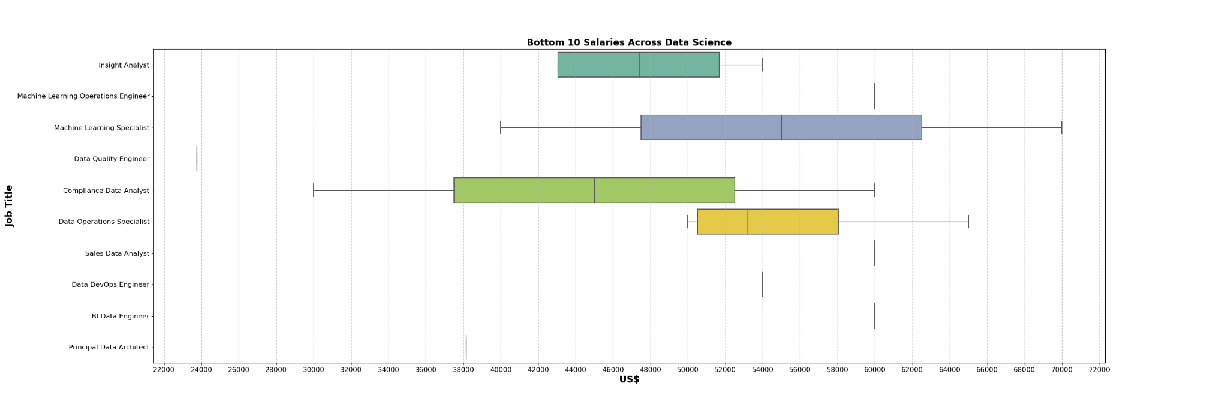

**Question 2 Comparison of Median Salaries Across Different Job Titles:**

**"How do median salaries vary across different data science job titles (e.g., Data Analyst, Data Scientist, Data Engineer, etc.)?"**

Salary Analysis of Data Professionals by Job Title

In our in-depth analysis of the salary data drawn from a diverse range of data-centric professions, the bar chart depicting median salaries unveils that certain job titles significantly outpace others in terms of compensation. For instance, the "Analytics Engineering Manager" sits at the apex of the salary hierarchy with a commanding median salary of approximately $399,880 USD, followed closely by "Data Science Tech Lead" with around $375,000 USD, and "Managing Director Data Science" at $300,000 USD. This suggests that leadership positions with a focus on analytics and data science command the highest median earnings, reflecting the high value and demand for such expertise in the marketplace.

On the other end of the spectrum, roles such as "Data Quality Engineer" and "Compliance Data Analyst" register median salaries at the lower end, around $23,753 USD and $45,000 USD, respectively, suggesting these positions might be aligned with entry-level qualifications or have a different industry valuation.

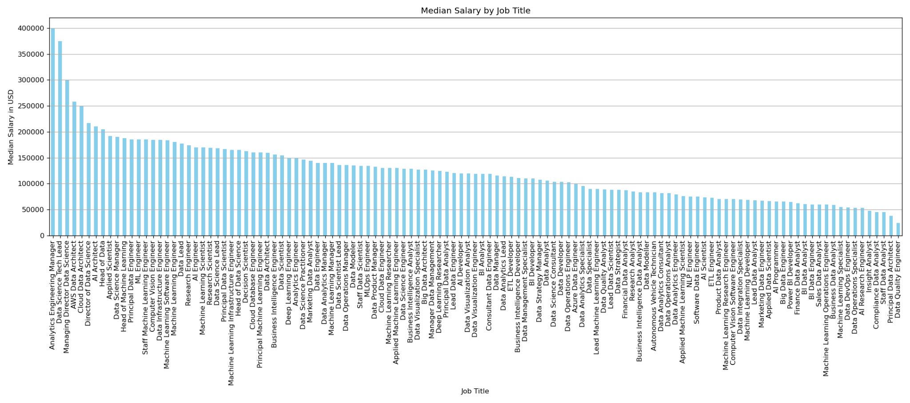

The box plot expands on these findings by providing a detailed view of the salary distribution for each job title, presenting a median salary (the 50th percentile) across all roles at $142,200 USD. Notably, the salary range is expansive, with the lower quartile (25th percentile) at $105,000 USD and the upper quartile (75th percentile) reaching $185,900 USD. This interquartile range of $80,900 USD captures the middle 50% of salaries, indicating a broad spectrum of earnings among data professionals.

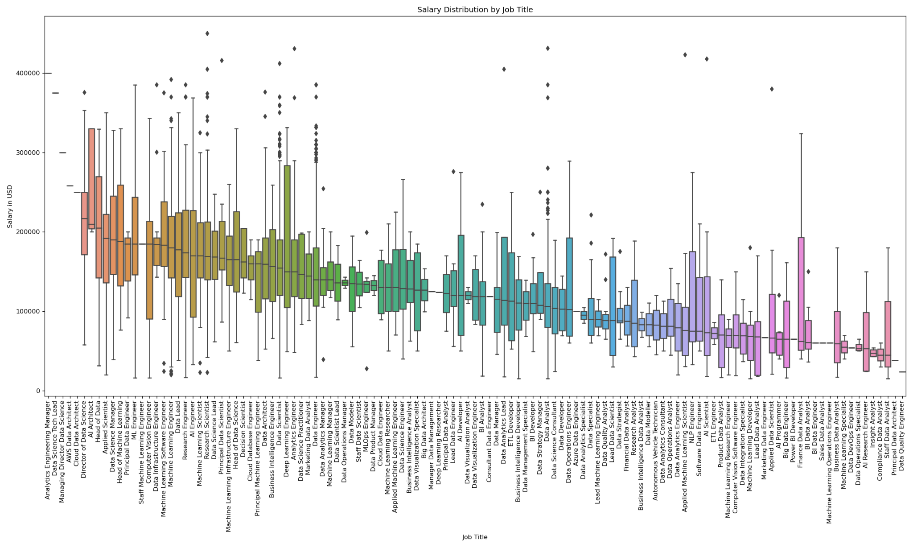

The analysis also reveals outliers, particularly where 147 salaries exceed the upper bound threshold of $307,250 USD. These outlier figures could be associated with highly specialized skills, extensive experience, or possibly roles within high-paying industries or regions.

In summary, our visual analysis underscores the heterogeneity of salaries within the data profession, shaped by a multitude of factors such as job title, experience, and market demand. As organizations strive to position themselves competitively in the data-driven market, this salary analysis could serve as a benchmark for structuring their compensation strategies, and for professionals within the field, it could inform career development choices and salary negotiations.

**Question 3 Salary Trends Based on Geographic Location:**

**“What are the trends in salaries for data science professionals across different regions or cities?”**

There is a very large disparity between the minimum and maximum salaries measured in USD. The lowest is Ecuador's average salary of $16,000, while the highest average salary belongs to Qatar at $300,000, almost 20 times as large.

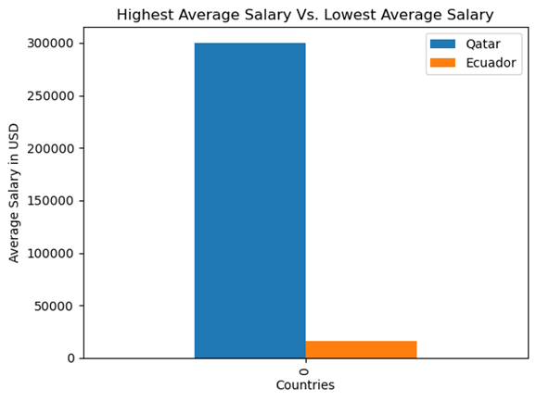

However, there does not appear to be a significant correlation between the region of the company and the average salary. The range of salaries is wide across all regions. Asia, Europe, and the Americas all have countries that are within both the lowest ten in average salaries as well as the highest ten. This suggests that there is no strong correlation between geographic location and salary trends in data science professions.

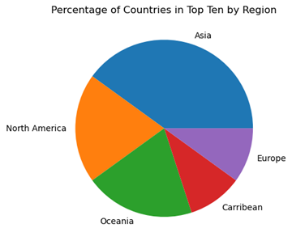

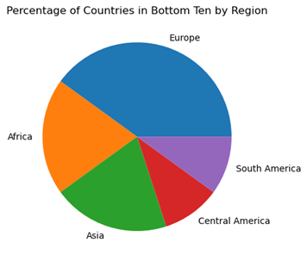

**Question 4 Impact of Experience on Salary:**

**"How does the level of professional experience impact the salaries of data science professionals?"**

Based on the Data provided there is a strong correlation between your level of experience and the average salary, this can be visualized in Chart 1. If you focus on the Median salary (blue bar) you will notice it has a significant increase for each level of experience listed starting from Entry (EN), Mid level (MI) , Senior level (SE) , and Executive / Director level (EX).

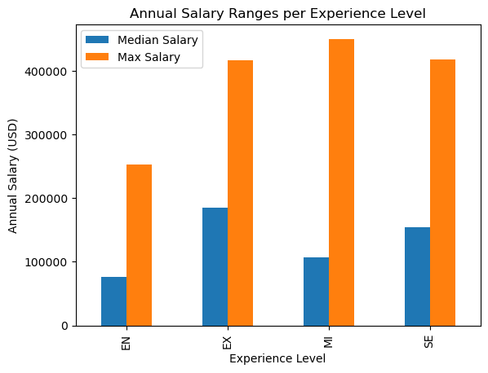

When delving deeper into the data you can see that not only does the level of experience affect your salary but also the size of the company you wish to join, when doing the Min , Median , and Max of this dataset based on both experience level and size of the company you find some interesting result. First is that like before as your level of experience rises so does your salary. However, to have the highest range of median salaries according to the Data you should work at a Medium sized company (50 to 250 employees). This was supported by the Data when you take the average of the median salaries across each level of experience per company size and divided by the levels of experience. The averages are as follows, Large Companies overall Median salary is ~$112,558, Medium companies overall Median salary is ~$134,025 and Small Companies overall Median salary is ~$93,183. This is demonstrated in Chart 2 below. It is my personal conjecture that Medium sized companies pay more on average for two reason, first is because they have to remain competitive against larger companies that are more likely to have larger compensation packages outside of just the base salary such as better insurance and more employee benefits like stock options , 401K match, and employee discount programs. The reason they pay more on average than Small companies is due to a larger resource pool and more opportunities to generate revenue.

